
COURSE: | ARTIFICIAL INTELLIGENCE
LAB: | #2
MEMBERS: | MUZAMMIL BIN SOHAIL (22F – 3110)  MUHAMMAD QAIM ALI (22F – 3142)  HARIS TARIQ (22F - 3088)  MURTAZA MEHDI (22F – 3101)
DEGREE: | BS - AI
SECTION: | 4A1

Question 1: (VACCUM CLEANER AGENT)
Screenshots:
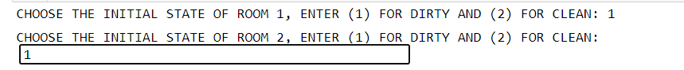
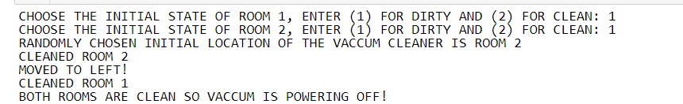
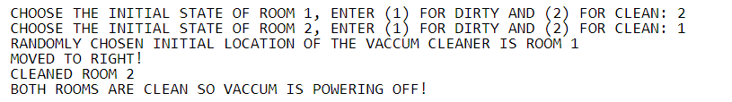
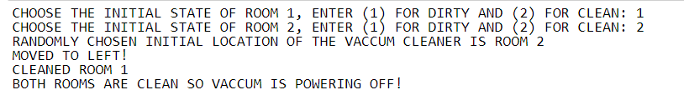
Code:
import random
class Room(object):
def __init__(self, state = "dirty"): #CONSTRUCTOR TO INITIALISE VALUES
self.state = state

class VaccumCleaner(object):
def __init__(self, location = 1): #CONSTRUCTOR TO INITIALISE VALUES
self.location = location

def sense(self, room1, room2, location): #SENSES THE CONDITION OF ROOMS AND LOCATION OF VACUUM CLEANER
if(room1.state == "dirty" and room2.state == "dirty" and location == 1):
return "dirty,dirty,1"

elif(room1.state == "dirty" and room2.state == "dirty" and location == 2):
return "dirty,dirty,2"

elif(room1.state == "dirty" and room2.state == "clean"and location == 1):
return "dirty,clean,1"

elif(room1.state == "dirty" and room2.state == "clean"and location == 2):
return "dirty,clean,2"

elif(room1.state == "clean" and room2.state == "dirty"and location == 1):
return "clean,dirty,1"

elif(room1.state == "clean" and room2.state == "dirty"and location == 2):
return "clean,dirty,2"

elif(room1.state == "clean" and room2.state == "clean"and location == 1):
return "clean,clean,1"

elif(room1.state == "clean" and room2.state == "clean"and location == 2):
return "clean,clean,2"

def decide(self, sensedData): #DECIDES THE SEQUENCE OF ACTIONS TO PERFORM IN RESPONSE TO THE DATA THAT IS SENSED
if(sensedData == "dirty,dirty,1"):
return "clean1,moveright,clean2"

elif(sensedData == "dirty,dirty,2"):
return "clean2,moveleft,clean1"

elif(sensedData == "dirty,clean,1"):
return "clean1"

elif(sensedData == "dirty,clean,2"):
return "moveleft,clean1"

elif(sensedData == "clean,dirty,1"):
return "moveright,clean2"

elif(sensedData == "clean,dirty,2"):
return "clean2"

elif(sensedData == "clean,clean,1"):
return "null"

elif(sensedData == "clean,clean,2"):
return "null"

def actuate(self, decision, room1, room2): #PERFORMS THE APPROPRIATE ACTION ON THE BASIS OF DECISION
if (decision == "clean1,moveright,clean2"):
self.suckDirt()
room1.state = "clean"
self.moveRight()
self.suckDirt()
room2.state = "clean"

elif (decision == "clean2,moveleft,clean1"):
self.suckDirt()
room2.state = "clean"
self.moveLeft()
self.suckDirt()
room1.state = "clean"

elif (decision == "clean1"):
self.suckDirt()
room1.state = "clean"

elif (decision == "moveleft,clean1"):
self.moveLeft()
self.suckDirt()
room1.state = "clean"

elif (decision == "moveright,clean2"):
self.moveRight()
self.suckDirt()
room2.state = "clean"

elif (decision == "clean2"):
self.suckDirt()
room2.state = "clean"

#MOVES THE VACUUM CLEANER TO LEFT IN ROOM 1
def moveLeft(self):
print("MOVED TO LEFT!")
self.location = 1

#MOVES THE VACUUM CLEANER TO RIGHT IN ROOM 2
def moveRight(self):
print("MOVED TO RIGHT!")
self.location = 2

#CLEANS THE ROOM BY SUCKING DIRT
def suckDirt(self):
print(f"CLEANED ROOM {self.location}")

#STARTS THE VACUUM CLEANER
def powerOnVaccum(self,room1, room2):
if(room1.state != "clean" or room2.state != "clean"):
sensedData = self.sense(room1, room2, self.location)
decision = self.decide(sensedData)
self.actuate(decision, room1, room2)

self.powerOffVaccum()

#SHUTS DOWN THE VACUUM CLEANER
def powerOffVaccum(self):
print("BOTH ROOMS ARE CLEAN SO VACCUM IS POWERING OFF!")

#GENERATES A RANDOM NUMBER 1 OR 2 TO IDENTIFY INITIAL LOCATION OF THE VACUUM CLEANER
def generateRandLoc():
return random.randint(1,2)

#CONTAINS THE DRIVER CODE OF THE AGENT i.e. VACCUM CLEANER
def main():
room1 = Room() #TWO ROOMS' OBJECTS DECLARED
room2 = Room()

if __name__ == "__main__":

#FOR INPUTTING VALID STATE OF ROOM 1
validState = False
while(validState != True):
roomState = int(input("CHOOSE THE INITIAL STATE OF ROOM 1, ENTER (1) FOR ""DIRTY"" AND (2) FOR ""CLEAN"": "))
if ( roomState != 1 and roomState!= 2):
print("INVALID ENTRY, ENTER AGAIN!")

else:
validState = True

if(roomState == 1):
state = "dirty"

else:
state = "clean"

room1.state = state

#FOR INPUTTING VALID STATE OF ROOM 2
validState = False
while(validState != True):
roomState = int(input("CHOOSE THE INITIAL STATE OF ROOM 2, ENTER (1) FOR ""DIRTY"" AND (2) FOR ""CLEAN"": "))
if (roomState != 1 and roomState!= 2):
print("INVALID ENTRY, ENTER AGAIN!")

else:
validState = True

if(roomState == 1):
state = "dirty"

else:
state = "clean"

room2.state = state

#validRoom = False
#while(validRoom != True):
#startingRoom = int(input("ENTER THE STARTING LOCATION OF THE VACCUM CLEANER, NOTE THAT THERE ARE ONLY TWO LOCATIONS AND YOU CAN ENTER (1) FOR ROOM A AND (2) FOR ROOM B: "))
startingRoom = generateRandLoc()
print(f"RANDOMLY CHOSEN INITIAL LOCATION OF THE VACCUM CLEANER IS ROOM {startingRoom}")
if (startingRoom != 1 and startingRoom!= 2):
print("INVALID ENTRY, ENTER AGAIN!")

else:
validRoom = True

vc = VaccumCleaner(startingRoom) #VACCUM CLEANER OBJECT DECLARED

vc.powerOnVaccum(room1, room2) #STARTING FUNCTIONALITY OF VACCUM CLEANER

main()

